Project #2

OpenMP: N-body Problem -- Coarse vs Fine and Static vs Dynamic

By Michael Rose

Due: April 26th 2016 (1 Late Day)

Written for: CS475 Spring 2016

Oregon State University

Table of Contents

What I did 3

What System I Used 3

Results 3

Analysis 3

# What I did

I step up a script that sets the number of threads and whether the code should be run coarse or fine. I output each coarse or fine and dynamic and static to 4 different CSVs. I then wrote a Python script that uses pull it to plot the data.

# What System I Used

I ran this on my local Linux box. It has an older model 4 core i5.

# Results

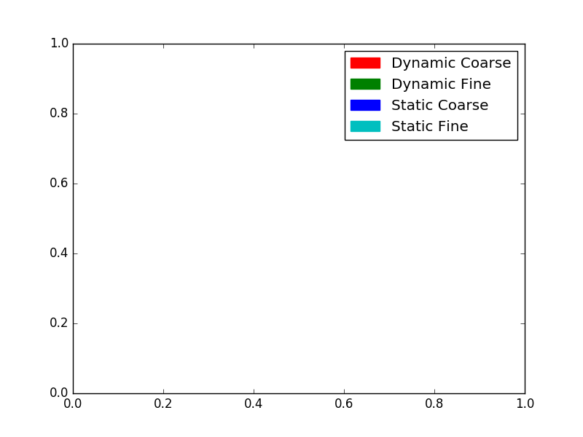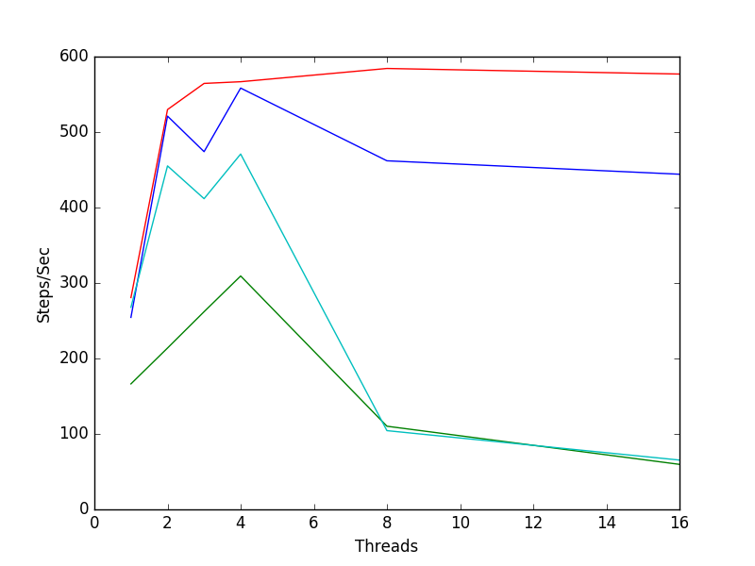

# Analysis

Coarse outperformed fine with both static and dynamic scheduling. This is because the fine breakdown tasks are too small and create extra work for the scheduler.

The fine performance is so fine that it overloads the dynamic scheduler even more causing dynamic scheduling to underperform for fine tasks. The threads are context-switching when they would be better off idling.

The coarse tasks are large enough that it benefits from dynamic scheduling and sees an increase. This is because there isn't an overload context-switching and the scheduler can load the cores up with more processes.